SHORT-TERM CONTRACT FOR MODELLING APPROACHES: SUPPORT TO BFT
ASSESSMENT (GBYP 06/2016) OF THE ATLANTIC-WIDE RESEARCH PROGRAMME ON
BLUEFIN TUNA (ICCAT-GBYP – Phase 6)
Tom Carruthers, Blue Matter Science Ltd. (bluemattersci@gmail.com)
19th September 2016
Progress Report 5

Overview of progress since Progress Report 4 (July – September 2016)
The MSE development workflow is sequential and requires certain prerequisites to achieve the deliverables of this contract. Prior to the July 2016 bluefin data preparatory meeting (Madrid) progress was dependent on finalization of the MSE Trial Specifications document and the provision of the necessary data to fit the M3 operating model to data and produce the outputs to support the ABT-MSE framework in R (upstream red boxes of Figure 1).

Figure 1a. MSE development prior to the 2016 data-preparatory meeting
The data-preparatory meeting addressed the core bottlenecks and since many of the downstream framework had been developed already, the project status is substantially more advanced just 2 months later (Figure 1b).
Figure 1b. MSE development prior to the 2016 bluefin species group meeting.
Several important steps have been taken in the last 2 months:
- The various forms of fishery and biological data were processed into the correct format for the M3 operating model (/RScripts/Build base OM.R, see /Manuals and design documents/Overview of code for constructing operating models.docx).
- An ‘operating model input’ object class (OMI) was designed in the ABT-MSE framework to organizes these formatted data and inputs and the most concise way possible (/Source/Objects.R).
- A Base OMI was created as a template from which to derive the various operating models of the MSE trial specifications document (/Objects/Reference OMs/Base_OM).
- Functions were designed to automate the writing of the OMI data/input into the M3 model data file (/Source/MSE_source.R).
Items 1-4 allow users to easily: exchange the pertinent data, modify model assumptions and rerun the operating model (greatly improving the ease with which users can re-fit the operating model given their particular set of assumptions).
- The current version of the M3 model (v1.0, alpha) was simulation tested to weigh the likelihood components of the various sources of data (catch observations, electronic tag tracks, fishery independent indices) correctly given how numerous and patchy the real data are.
- The length-selectivity functions were re-parameterized to improve fit to the length composition data and increase model stability.
- The M3 users guide and software design documents were updated for version 1.0.
- The various alternative scenarios of the trial specification document were programmed as functions that are applied to an OMI object. This means that a single Base OMI acts as a template from which the scenarios of the Trials specifications are derived (in total 24 operating models, see Table 1) (/Source/MSE_source.R). A dedicated folder for each operating model was created that stores the OMI and the outputs of each M3 run (/Objects/Reference OMs).
- An operating model report function was coded (R markdown) that takes the outputs of any M3 model run and creates a .pdf report that shows the key model estimates, the fit to observed data and the statistical properties of the fit to indices of abundance that may be used in the future by management procedures (/Source/OMreport.Rmd).
- The operating model report was created for each of the 24 OM runs and stored in the dedicated folder for that operating model (/Objects/Reference OMs).
The three most significant outstanding components of the MSE process are central to the fundamental purpose of the project and depend on wider consultation and participation: definition of performance metrics, specification of management procedures and evaluation of trade-offs (Section 4 below). Following the species group meeting (September 2016) the priority is final production of a software design document and manual that allows for rapid testing of new user-specified management procedures and the derivation of custom performance metrics (consistent with the workplan, Section 5 below).

Current status of deliverables and actions required to achieve them
Deliverable 1 July 20, 2016 (100%)
 | i | Workplan outlining the actions required to complete the 5 components of deliverable 3
 | ii | Presentation and short report summarizing current status of deliverables and actions required to achieve them
The purpose of Progress report 4 and accompanying presentations was to address deliverable ii. The workplan (deliverable i) is reiterated in Section 5 below.
Deliverable 2 September 23, 2016 (66%)
 | i | Updated presentations and short report summarizing current status of deliverables and actions required to achieve them
 | ii | Demonstrator showing the MSE running, should include examples of the 6 steps of developing an MSE
 | iii | Draft papers on applications
The purpose of this report and accompanying presentations is to address deliverable i.
A demonstration MSE run is now available (/RScripts/MSE_demo_1.R) to address deliverable ii including where possible, the appropriate steps of MSE development (Punt and Donovan 2006:
(1) qualitative specification and prioritization of the management objectives, as derived from legislation, legal decisions, and international standards and agreements;
(2) quantification of the qualitative management objectives in the form of performance measures;
(3) development and parameterization of a set of “operating models” that represent different plausible alternatives to the dynamics of the “true” resource and fishery being managed;
(4) identification of candidate management procedures, including monitoring strategies;
(5) simulation of the future use of each candidate management procedure, involving for each time-step during the projection period: (a) generation of assessment data; (b) determination of the management action (i.e. assessment and application of some HCR); and (c) evaluation of the biological implications of the management action by removing the catch from the population as represented in the operating model;
(6) summary of the performance of the candidate management procedures in terms of values for the performance measures; and
(7) selection of the management procedure that best meets the specified objectives.
A summary demonstration of MSE results will be set up in a shiny app (e.g. http://rscloud.iccat.int:3838/gbyp-mse/) following feedback from the bluefin WG, CMG and stakeholders on the design of this graphical tool.
Due to the delay in obtaining the suitable data / inputs to the operating model, no papers on applications were produced in time for this September species group meeting (the operating models were fitted September 17th following the provision of maturity and growth curves). Feedback is being sought at the meeting regarding appropriate applications and the subject of a peer-reviewed paper based on the MSE and operating models.
Deliverable 3 Draft: February 13, 2017 Final: February 21, 2017 (33%)
 | i | Repository with version control for software development http://github.com/ICCAT/abt-mse containing the OM (~100%)
 | ii | SDP (Software Development Plan) that will be reviewed by external experts, as agreed at Monterey meeting (~50%)
 | iii | Test Unit so that code can be validated (~80%)
 | iv | Meta Database summarizing all parameters and assumptions used http://github.com/ICCAT/GBYP-MetaDB (0%)
 | v | Management Procedures Support the implementation of 3rd parties. Written up as SCRS paper and code available in repository (0%)
(i) Following the completion of version 1.0 of the M3 operating model, the ICCAT MSE GitHub site will now be subject to regular (weekly) updates following developments to code and software documentation. Branching, merging, pulls, commits etc. may be managed either by me the Technical Assistant or ICCAT staff.
(ii) The software development plan is a current task. Updated software design documents and manuals are available for the M3 operating model (v1.0). Following feedback from the bluefin working group (BFT WG), core modelling group (CMG) and SCRS the SDP for the ABT-MSE R framework can be finalized and a manual and software design document can be wrapped up before November 2016.
(iii) A test unit has been developed that matches the new features of the latest M3 model (v1.0). The simulator is built into the R ABT-MSE framework and uses streamlined operating model objects (OM definition objects) to generate simulations and calculate reference points. The test unit (and M3 model) must both be updated to reflect recommendations of the CMG, BFT WG and SCRS following the 2016 data preparatory meeting. The simulation testing framework (test unit) will be updated to simulate data from the dynamics of the fitted operating models (noting that simulation testing of the full operating model (55 years, 4 seasons, 10 areas, 14 fleets) will be considerably more computationally intensive than previous simulation tests.

Current status of objectives
Objective |  | Tasks (bold are completed)
a  (100%) | Continue the development of the OM based on the MSE trial specifications document (TS) | Added (M3 v1.0):  age-based movement, plus group, model initialization at equilibrium estimated F, recruitment predicted from SSB in previous year, a prior for depletion to allow the model to fit specified depletion.
b  (100%) | Develop a test unit to validate the age-based movement model | Test unit updated to match developments in the operating model above (a)
c  (0%) | Work with third parties to add MPs to the MSE framework including empirical control rules and simple stock assessment methods | Reach out to national scientists, members of the BFT WG (possibly leverage the chairs of Eastern and Western WGs) and the CMG to develop new MPs or to incorporate existing MPs (e.g. CCSBT)
d  (0%) | Run the MSE in collaboration with BFT Species group | Requires a dedicated meeting following finalization of the TS, fitting of the appropriate OMs and integration of these into the R ABT-MSE framework.
e  (50%) | Collaborate with the SCRS to develop interactive graphics (e.g. Shiny apps) to communicate MSE results to stakeholders based on the performance metrics of the trial specifications document | A preliminary Shiny App is now available at: http://rscloud.iccat.int:3838/gbyp-mse/  The App should be modified following feedback from the BFT WG and stakeholders.  The App should include sufficient flexibility to allow users to define their own OMs.
f  (0%) | Work with other to update and maintain the meta database of the available bluefin data and knowledge https://github.com/ICCAT/GBYP-MetaDB | During and after the 2016 data preparatory meeting, discuss data availability and collaboration with those data providers listed in the MetaDB
g  (0%) | Work with SCRS to help develop 3 prototype examples

Addressing critical issues for MSE adoption

Stakeholder specification of OMs
There are two levels at which stakeholders may specify OMs. The first is at the ground level in the description of the trial specifications document (TS). This determines the range of scenarios that the OM (M3) will be fitted to data.
The second level is post-hoc and may be achieve through various combinations of the OM conditions identified in the TS. For example a stakeholder may select a unique combination of mortality rate, stock depletion, stock-recruitment relationship, bias in reported catches and test MP robustness to this particular reference case. The creation of the OMI (Operating Model Input) class object greatly simplifies the process of custom OM specification as it contains a slot for all of the M3 model inputs in the correct format (for example the maturity schedule for each stock). The second level of stakeholder specification may be achieved through graphical MSE summary tools such as a shiny app. An online interactive table may be updated to allow for various OM types to be added by stakeholders.

User-specified MPs
The ABT-MSE R framework is designed specifically to allow user defined MPs to be easily incorporated. The central obstacles for successfully engaging with stakeholders on MP development are materials (tutorials, examples, demos) that clearly explain this functionality. An example MP (http://iccat.int/Documents/CVSP/CV071_2015/n_6/CV071062790.pdf) will be coded into the package as part of a tutorial on custom MPs. It may be necessary to organize a dedicated MSE workshop once a working MSE framework is established.

Custom performance metrics
The process of establishing management objectives (e.g. biomass above BMSY) and target performance metrics (probability of being above 50% BMSY after 10 years) relies on engagement with stakeholders. Typically this is an iterative approach and stakeholder require working MSE results to begin an informed decision about types of performance (short term yield, long term yield, stability in yield, biomass levels) targets and limits for these and probabilities of exceeding these. Interactive tools such a shiny apps and Bayesian belief networks offer a possible means of making MSE outputs accessible to stakeholders with a wide range of backgrounds and abilities.

Workplan for achieving deliverable 3
Following the data preparatory meeting, it was clear that the data for the operating models would become available earlier than scheduled under the previous workplan of report 4 (see Figure 2 for the latest workplan and changes from previous version). However the meta-database has yet to be completed pending finalization of maturity, growth model and inverse age-length key derivation at the 2016 species group meeting (outstanding issues below). This however is a relatively minor task and should take a few days following the species group meeting.
A demonstration MSE is a part of deliverable 3 and should include user-specified MPs, and performance metrics that have been subject to review by stakeholders. However, the previous workplan did not acknowledge a prior, more cursory demonstration MSE that is part of deliverable 2 which is now reflected in the updated Gantt chart (Demonstration MSEs 1 and 2).
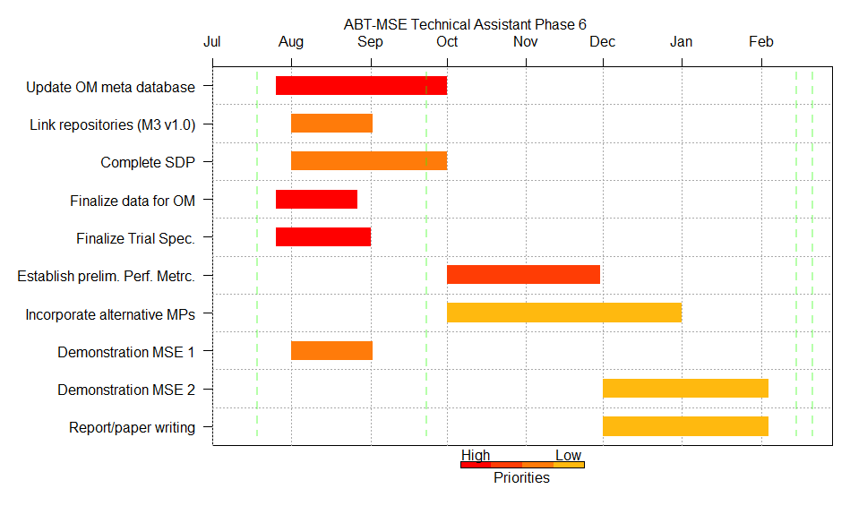
Figure 2. Updated Gantt chart of possible workflow for MSE technical assistant 2016-2017 following adherence to Deliverable 2 and provision of OM data following data preparatory meeting. Black annotations highlight differences from previous workplan (of progress report 4).

Repository with version control (Complete, August 2016)
The most recent version of the M3 operating model I the first to be simulation tested and fitted to the operating models of the trial specifications document. This constitutes a first working example that is fit for purpose (v1.0). The ICCAT MSE GitHub repository is now linked with local repositories and will be updated on a regular basis to reflect changes in code and software documentation.

Software development plan (October 2016)
A manual and software design document are available for the latest version of the M3 operating model (/Manuals and design documents/). A software design document and manual is currently being drafted for ABT-MSE R framework.

Test unit (Complete, Jul 2016)
The test unit is essentially complete for v1.0 of the M3 operating model but requires more sophisticated observation error models, potentially for new sources of information such as close-kin genetics analysis and standard gene tagging.

Meta database (TBD depending on feedback, simple Excel version September 2016 following data preparatory meeting)
Carruthers (2015c) describe a cursory attempt to develop a meta database describing the types, availability and ownership of various data for condition OMs. This simple excel worksheet may not provide sufficient detail and flexibility to accommodate all data. There are two options: continue to update and expand the current worksheet perhaps making this an online document using google sheets. The other option is a wholesale overhaul and redevelopment to a more dedicated and powerful data base engine. This should be a topic for discussion of the CMG members at the September species group meeting.

User-defined MPs (Prior to Jan 2017)
The current ABT-MSE R framework allows for rapid design and incorporation of user-specified MPs. The precursor to this is clear documentation (the ABT-MSE R framework manual is under development and will be finalized once OM and TS have been finalized). Additionally a tutorial and potential a demo video could also help prospective MP designers become acquainted with the simulation framework and outputs.

Other outstanding issues

Provision of electronic tagging data in requirement format
A large number of potentially informative electronic tags were provided by the Stanford lab, but without covariate length / age data with which to assign tags to age classes (e.g. age class one: 0-3 years, age class 2: 3-8 years, age class 3: 9+ years). These data are currently not used in the conditioning of operating models despite their potential value.

Development of inverse age-length keys
Inverse age-length keys (probability of a fish being of length class L given age class A) were derived by me using a very naïve approach (ie superimposing a 10% coefficient of variation around the maximum likelihood fit of the Richards growth curve following Allioud et al.). Time – varying iALKs are accepted by the M3 operating model that may be better derived empirically from the raw age-length data.

Changes to operating model structure
The modelling and estimation of recruitment deviations prior to the initial model year was deemed of secondary importance following the guidance of the core modelling group in Monterey (January 2016). However on examining the fit of the M3 model to the master abundance indices it is apparent that without the estimation of historical recruitment the model cannot fit initial ‘bumps’ in abundance that are inferred by indices. Incorporating these changes is reasonably trivial (a few days) and a priority following the September species group meeting.

Derivation of a master relative abundance index
Currently a master relative abundance index is derived in an ad-hoc manner using coarse task II catch and effort data by me the technical assistant. This index is very important to the conditioning of operating models because it infers the temporal trajectory and spatial distribution of both stocks combined. Given its importance, this index should be derived by more detailed data (trip level data) and subject to careful review by a range of stakeholders.

